Using Storyboards to identify how refugee men might be able to assist in the fight for gender equality.

Suggested Gender Equality questions to use with men and boys:
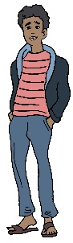
- What are some of the reasons men resist programs aimed at creating more equality for women?
- What would be the worst things that could happen if women gained more equality?
- What would be the benefits to the community if women and girls did gain more equality?
- What needs to be done to address these fears and encourage gender equality, what support, and resources would the groups to do this?
- Who can help with this?
- What would be the positive outcomes of this happening?

