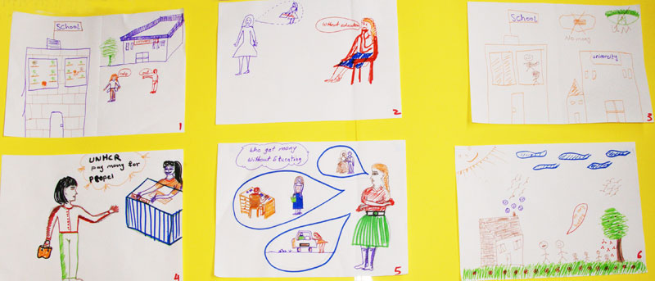
Storyboarding questions could cover:
- Depict a problem of concern experienced by people in your community. (An example might be the lack of education by women and girls)
- How does it affect the people concerned, what happens to them, how does this affect their families, their communities?
- What happens to these women and girls now? (What help is available to them and is it effective?)
- If you were in charge of services for this group of people, what would you provide for them their families and the community in order to address this issue?
- Who do you think could provide these services? Who would you want to do this? What help would WRLOs need to address it?
- If all these services were available what would be the best outcome for these participants?

